LAB EXPERIMENT RECORD
Set 1:

Department | AIDS
Course Code / Course Name | DSA0601 / Data Handling and Visualization
Experiment | Data Visualization using R
Name | AYESHA SIDDIQA S
Register Number | 192324305
Date | 29 September 2026
Day | Tuesday

1.Aim
To create a line chart in R to visualize the performance trend of employees and include appropriate labels and a legend.
Algorithm
- Create vectors for employee ID and performance score.
- Store the employee data in R.
- Use the plot() function to create a line chart.
- Add axis labels and a title.
- Add a legend to identify the performance score.
- Display the chart.
Code
employee_id <- c(1, 2, 3, 4, 5)
performance <- c(85, 92, 78, 90, 76)

plot(employee_id,
performance,
type = "o",
col = "blue",
xlab = "Employee ID",
ylab = "Performance Score",
main = "Employee Performance Trend")

legend("topright",
legend = "Performance Score",
col = "blue",
lty = 1,
pch = 1)
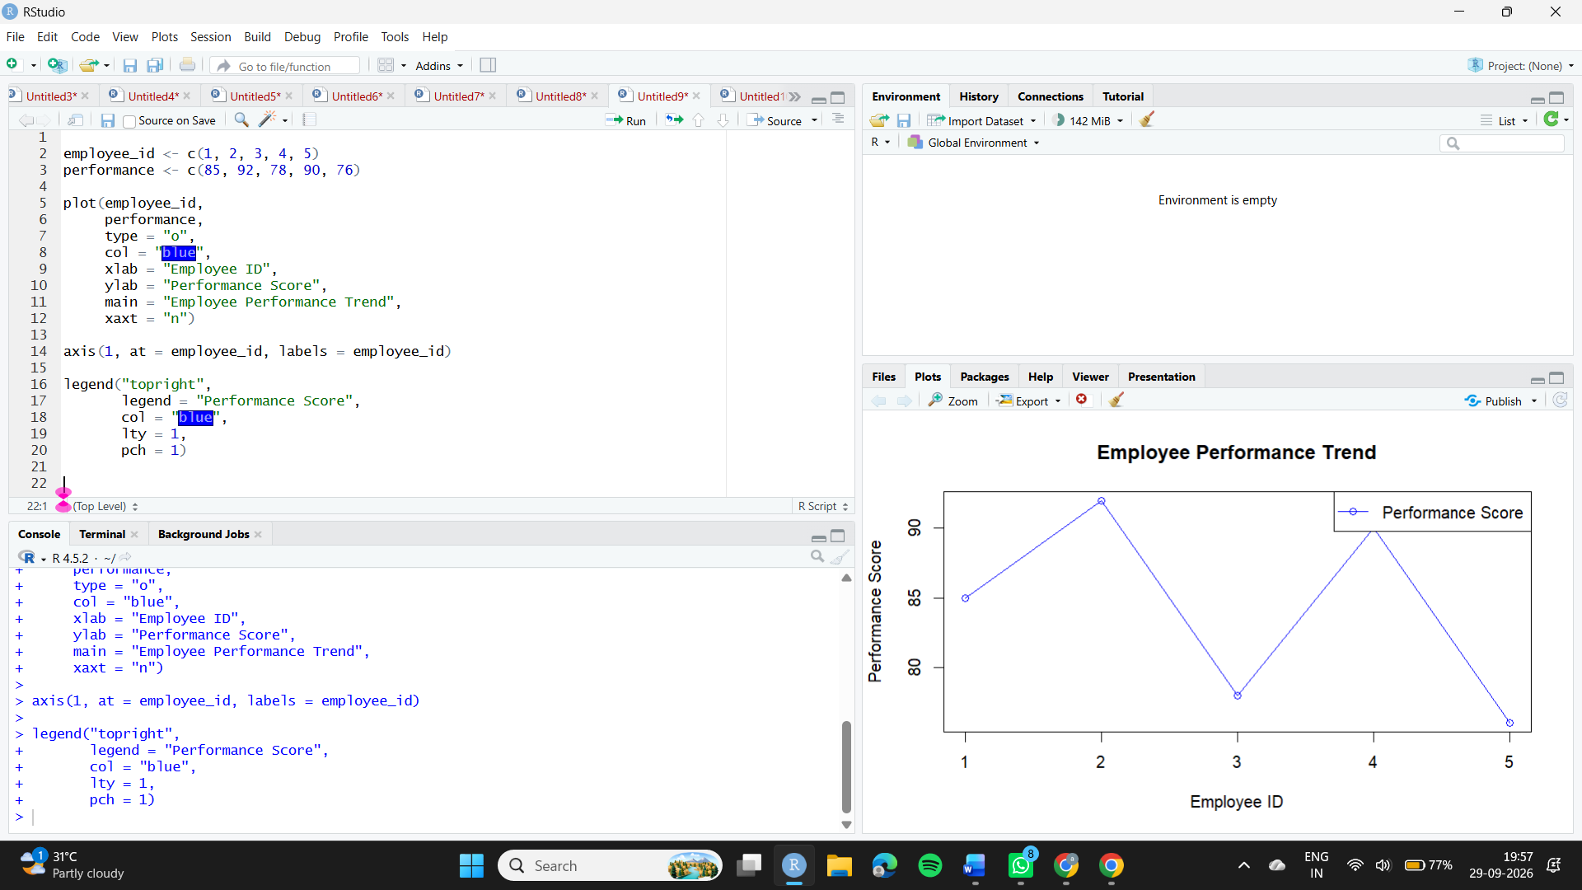
Observation
The line chart shows the performance scores of the five employees. Employee 2 has the highest score of 92, while Employee 5 has the lowest score of 76.
2. Aim
To create a bar chart showing the distribution of employees across different departments.
Algorithm
- Create a vector containing department names.
- Count the number of employees in each department using table().
- Use barplot() to create the bar chart.
- Add labels, title, and axis names.
- Display the chart.
Code
department <- c("Sales", "HR", "Marketing", "Sales", "HR")

department_count <- table(department)

barplot(department_count,
col = "green",
xlab = "Department",
ylab = "Number of Employees",
main = "Employees by Department")
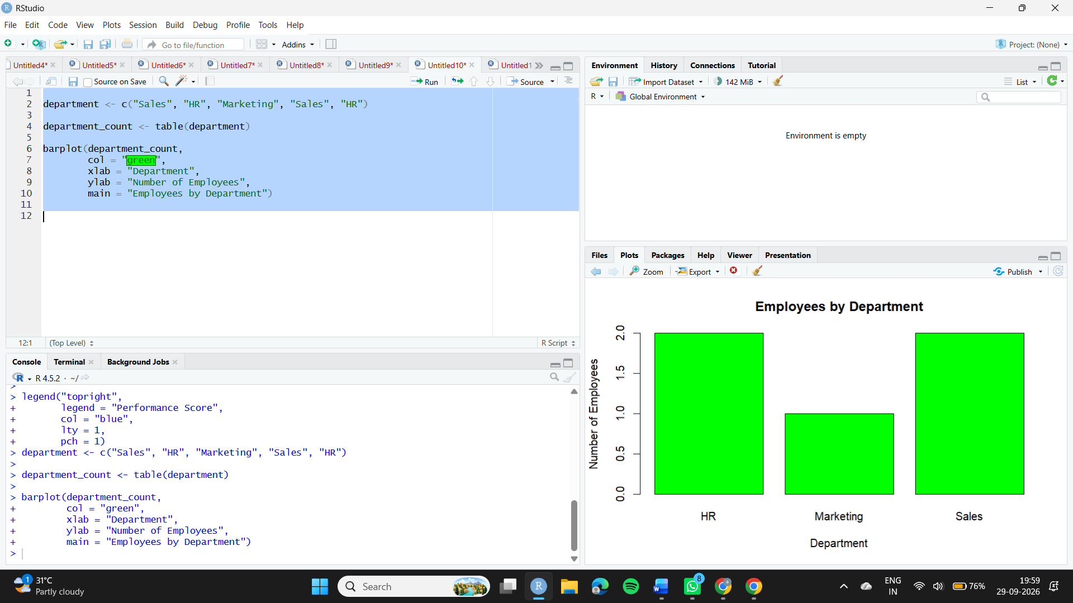
Observation
The Sales department has 2 employees, HR has 2 employees, and Marketing has 1 employee.
3.Aim
To create a scatter plot to analyze the relationship between years of service and employee performance scores.
Algorithm
- Create vectors for years of service and performance scores.
- Plot years of service on the X-axis.
- Plot performance score on the Y-axis.
- Add a regression line using lm().
- Add appropriate labels and title.
- Observe the relationship between the variables.
Code
years <- c(5, 3, 7, 4, 2)
performance <- c(85, 92, 78, 90, 76)

plot(years,
performance,
pch = 19,
col = "red",
xlab = "Years of Service",
ylab = "Performance Score",
main = "Years of Service vs Performance Score")

abline(lm(performance ~ years),
col = "blue",
lwd = 2)
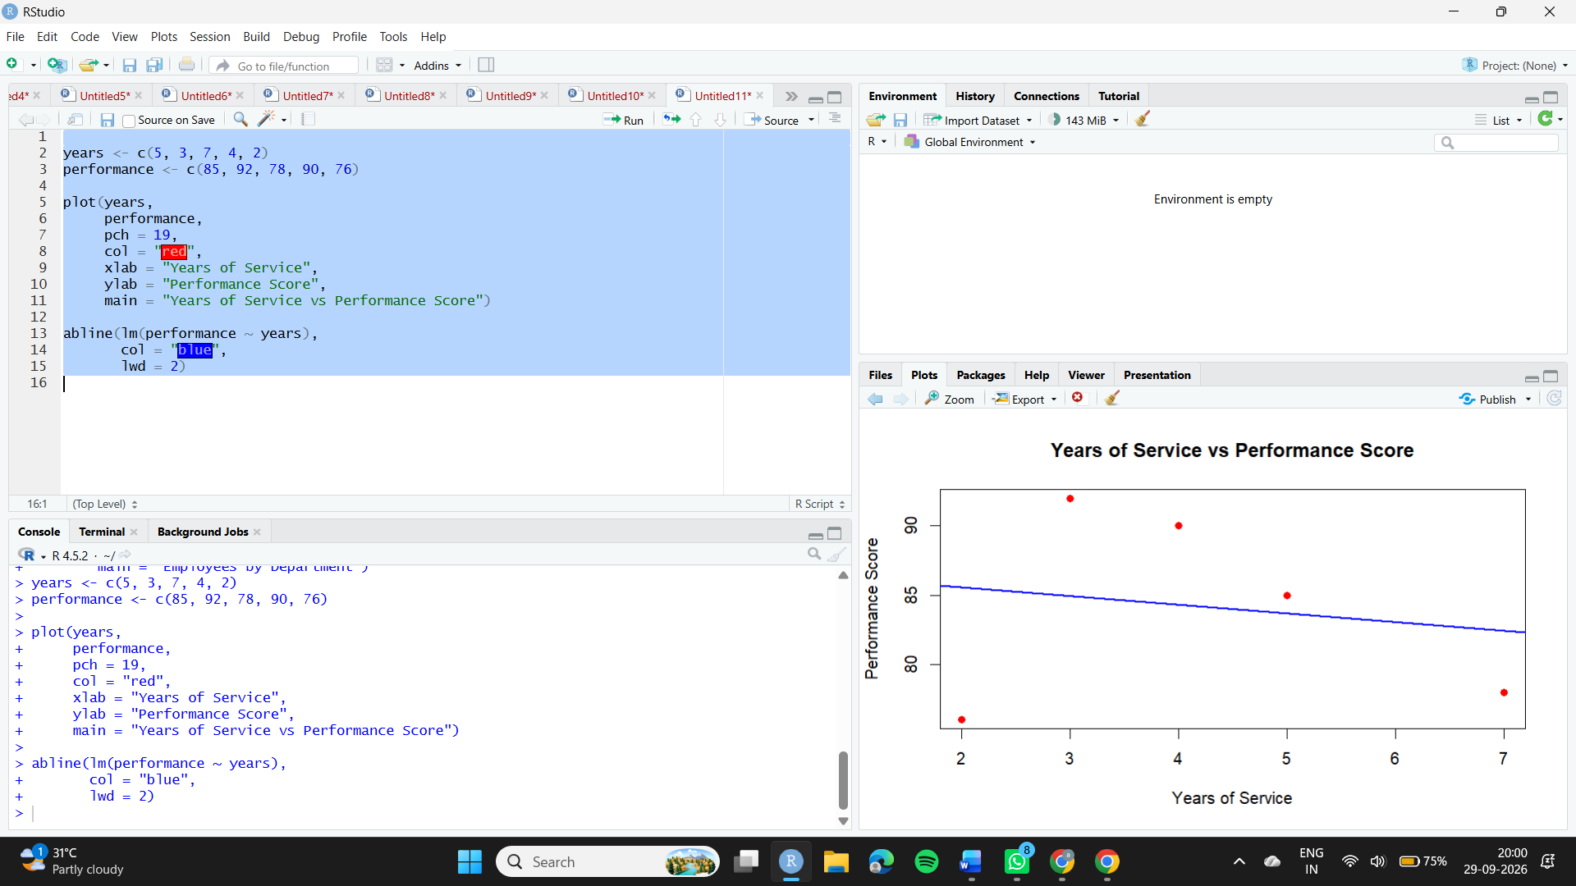
Observation
The scatter plot shows a weak negative relationship between years of service and performance score in this small dataset. Employees with more years of service do not necessarily have higher performance scores. Since there are only five employees, this observation should not be generalized.
Aim
To develop an interactive Tableau dashboard combining the employee performance line chart and department distribution bar chart.
Algorithm
- Enter the employee dataset into Excel or CSV format.
- Open Tableau and connect to the dataset.
- Create a line chart using Employee ID and Performance Score.
- Create a bar chart using Department and Employee ID count.
- Create a new dashboard.
- Add both charts to the dashboard.
- Add filters for interactive exploration.
- Save and display the dashboard.
Procedure
Step 1: Create an Excel/CSV file containing:
Employee ID | Department | Years of Service | Performance Score
1 | Sales | 5 | 85
2 | HR | 3 | 92
3 | Marketing | 7 | 78
4 | Sales | 4 | 90
5 | HR | 2 | 76
Step 2: Open Tableau → Connect → Microsoft Excel/CSV and select the dataset.
Step 3: Create Sheet 1 – Performance Trend
- Drag Employee ID to Columns.
- Drag Performance Score to Rows.
- Select Line from the Marks card.
- Add title: Employee Performance Trend.
Step 4: Create Sheet 2 – Department Distribution
- Drag Department to Columns.
- Drag Employee ID to Rows.
- Change aggregation to COUNT.
- Select Bar Chart.
- Add title: Employees by Department.
Step 5: Create a new Dashboard and drag both sheets into it.
Step 6: Add a Department filter to allow interactive exploration.
Observation
The Tableau dashboard combines employee performance and department distribution in one interactive view. Users can select departments using the filter and explore the corresponding employee information.

